**Question 1:**

**Find out the mail servers of the following domain :**

Ibm.com

Wipro.com

**Question 2: Find the locations, where these email servers are hosted.**

***Ans.***

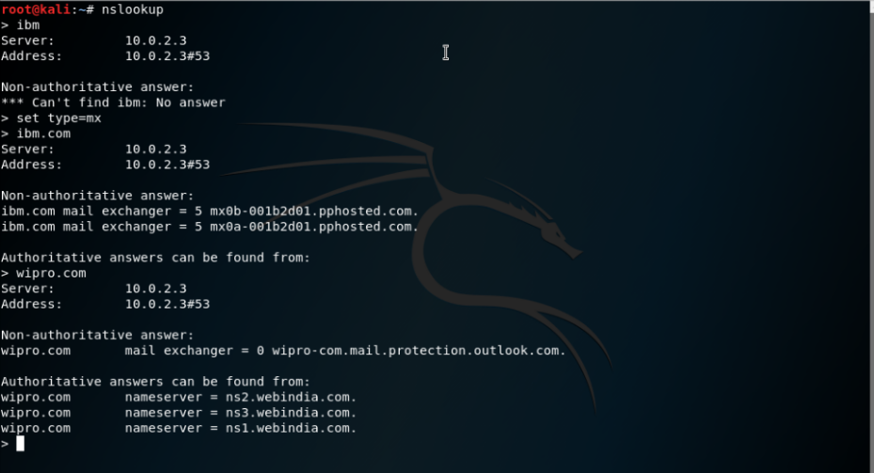

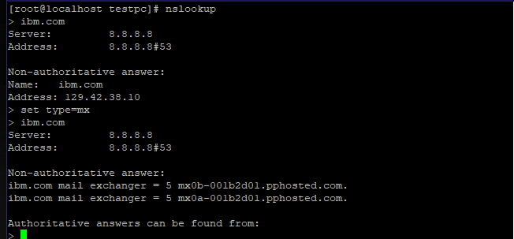

**Ibm mail server location :**

ip : 148.163.158.1, 148.163.158.5

city : Sunnyvale

Region : California

Country : USA

**Wipro mail server location:**

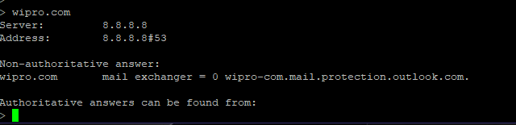

Ip : 104.47.124.36

City : Hong Kong

Region : Hong Kong

ISP : Microsoft Corporation

**Question 3: Scan and find out port numbers open 203.163.246.23**

*\*\*Scan Ran via an online test server.*

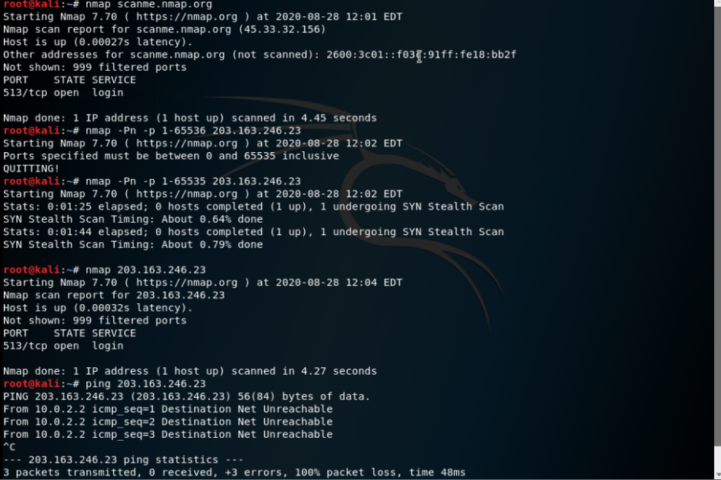

**Question 4: Install nessus in a VM and scan your laptop/desktop for CVS.**

*\*\*Could not run VM machine so ran Nessus on a Centos Server,*

*Test report - html file and pdf before and after update in the github repo provided.*